DVD Lifestyle Intervention (DELITE)

DEPARTMENT OF VETERANS AFFAIRS

VA Puget Sound Health Care System

1660 South Columbian Way

Seattle, WA 98108-1597

Dear DELITE Participant:

Thank you for your participation in the VA study “DVD Lifestyle Intervention (DELITE).” We are writing to share the study findings now that they have been published, and to thank you again for your study participation.

The investigators developed DELITE to find out if a remotely-delivered, self-directed behavioral lifestyle intervention improves weight and general health status among adults with obesity. This clinical trial showed that, compared with usual care, the intervention resulted in:
- statistically significant difference in weight loss that was not clinically important, and
- no significant difference in physical health status at 12 months.

These results were published in the Journal of the American Medical Association (JAMA. 2022;328(22):2230-2241. doi:10.1001/jama.2022.21177). You can read the full article by:
- typing this address in your web browser: https://jamanetwork.com/journals/jama/article-abstract/2799407, or
- scanning this QR code:

The visual abstract is pasted below:
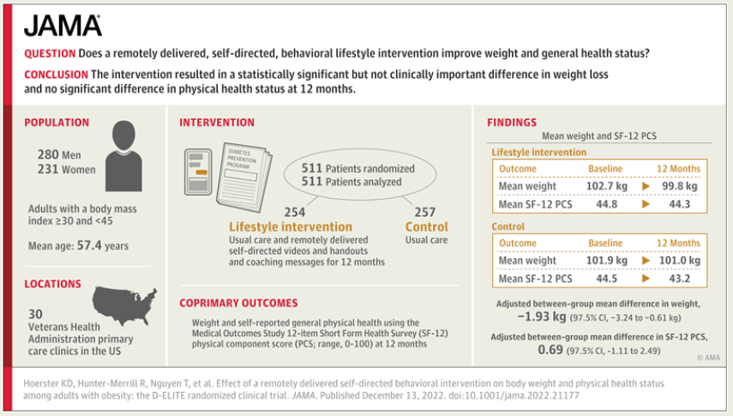

Your participation in the study is helping us learn about how to best support Veterans with obesity. We are so grateful for your participation. If you have any other questions about the study, feel free to contact 206-277-4203.

Sincerely,

Katherine Hoerster, PhD, MPH
Staff Psychologist, Mental Health Service
VA Puget Sound Health Care System

